
Company
Logotype

Cone Beam Computed Tomography- Report



Porur Dental X-rays & CBCT

Patient Name : Mrs. Divya | Date of Report : 09.05.2024
Age/ Gender : 35 years/ Female | Region of Interest : CBCT Full Skull
Referring doctor: Dr. S. M. M. Moulvi | Indication : Implant assessment
Clinical Notes: Nil
PATIENT INFORMATION

CBCT- Full Skull provided
CBCT – IMAGE DETAILS

RADIOGRAPHIC INTERPRETATION

- Completely missing crown and root portion in relation to 18, 28, 35, 38, 48.
- The alveolar bone in relation to 35 region is present with normal trabecular pattern.
- In relation to the left maxillary sinus, presence of hyperdense opacification occupying more than 2/3rd of the sinus volume is evident.
- Presence of antral septae within the right and left maxillary sinus is evident.

IMPLANT ASSESSMENT

 | 35 region
Sub-Crestal (in mm) | 3.8
Mid- Crestal (in mm) | 5
Distance between alveolar ridge and the inferior alveolar nerve canal (in mm) | 14.5
Distance between alveolar ridge and the inferior border of mandible (in mm) | 21.8

RADIOGRAPHIC IMPRESSION

- Partially edentulous mandibular arch.
- Left maxillary sinusitis.

Kindly correlate with clinical findings


IMAGES FOR REFERENCE

RECONSTRUCTED PANORAMIC VIEW

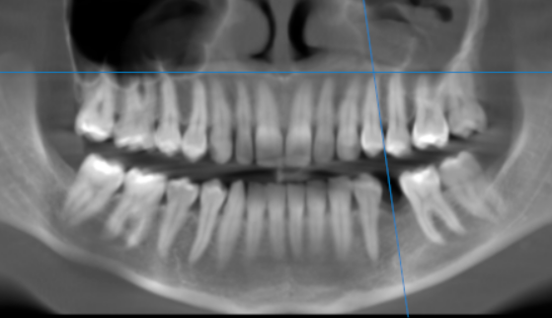

3-DIMENSIONAL VIEW
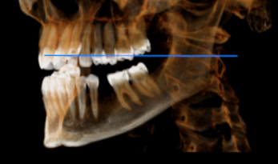

MULTIPLANAR VIEW DISPLAYING THE MAXILLARY SINUS
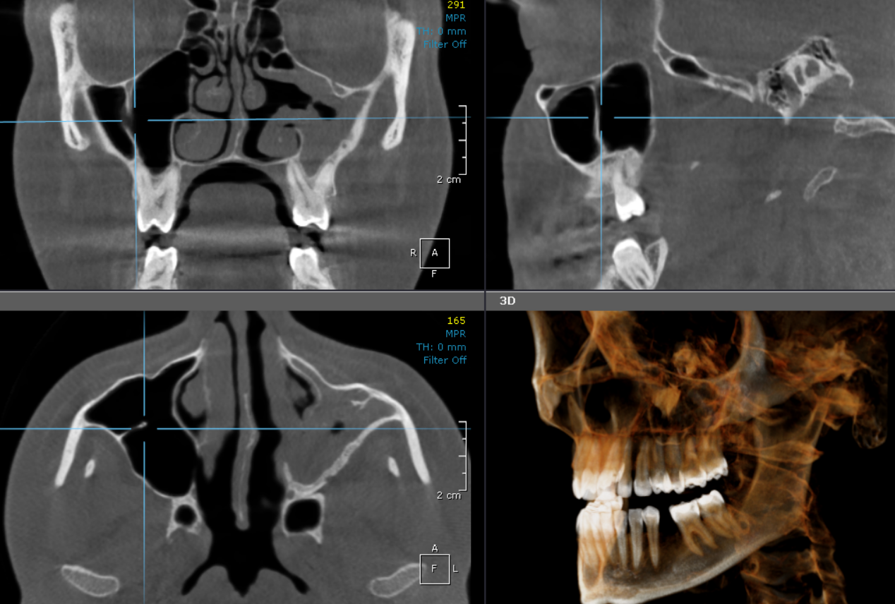

CROSS SECTIONAL VIEW

35 region | 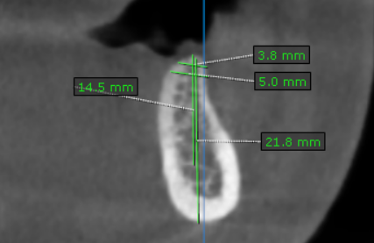

**** End of report ****

